

**MSc.Agriculture Analytics**

**COURSE NAME : Earth Observation System**

**COURSE NO: MA613**

**PROJECT TITLE : Medical Thematic Mapping**

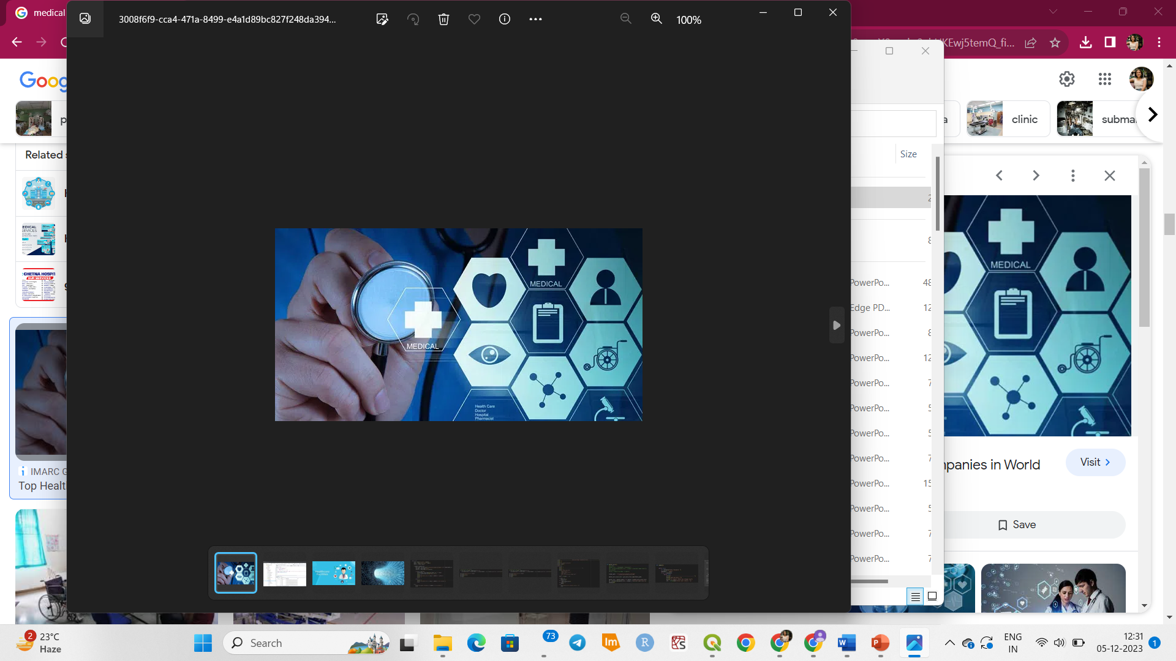

**Submitted to: Submitted by:**

**Dr. Ranendu Ghosh Akriti Dhyani**

**Dr. Viral Dave 202319018**

**Anusha Parida**

**202319026**

**Manisha Shetty**

**202319028**

**INTRODUCTION:**

**Scope of Medical Facility Thematic Maps:**

1. **Geographic Distribution Analysis:**
   * Thematic maps provide a visual representation of the spatial distribution of medical facilities, allowing for a comprehensive analysis of their locations.
2. **Type and Specialization Identification:**
   * The maps help in identifying the different types of medical facilities (hospitals, clinics, pharmacies).
3. **Capacity Assessment:**
   * Thematic maps can be used to analyse the capacity of healthcare facilities.
4. **Demographic Considerations:**
   * Thematic maps can be overlaid with demographic data to understand how the distribution of medical facilities aligns with the characteristics of the population.
5. **Public Health Planning:**
   * By identifying areas with concentrations of medical facilities or potential gaps, planners can make informed decisions to improve public health outcomes.

**Importance of Medical Facility Thematic Maps:**

* **Resource Allocation:**

Helps policymakers allocate resources effectively by understanding where healthcare facilities are most needed based on population distribution and health needs.

* **Emergency Response Planning:**

In times of emergencies or pandemics, these maps assist in planning response strategies by identifying critical healthcare infrastructure and potential surge capacity.

* **Healthcare Equity:**

Supports efforts to address healthcare disparities by highlighting areas with limited access to medical facilities, allowing for targeted interventions.

* **Infrastructure Development:**

Guides the planning and development of new medical facilities by identifying areas with insufficient capacity or those experiencing population growth.

* **Data-Driven Decision-Making:**

Enables data-driven decision-making for healthcare administrators, policymakers, and public health officials, leading to more efficient and effective healthcare planning.

* **Public Awareness and Education:**

Raises public awareness about the availability and distribution of healthcare services, promoting informed decision-making regarding healthcare choices and accessibility.

* **Epidemiological Studies:**

Supports epidemiological studies by providing spatial context, helping researchers understand the relationship between healthcare facility distribution and disease prevalence.

* **Optimizing Healthcare Networks:**

Facilitates the optimization of healthcare networks by identifying areas where collaboration between different types of facilities can improve overall healthcare delivery.

**Key Features of the Thematic Map:**

1. **Spatial Distribution:**
   * Illustrates the geographical spread of medical facilities, including hospitals, clinics, and pharmacies across a given region.
2. **Symbolization of Facilities:**
   * Utilizes symbols or icons to represent different types of medical facilities, making it easy to distinguish between hospitals, clinics and pharmacies.
3. **Color-coded Layers:**
   * Uses color-coded layers to convey information about the facilities in different taluks of Gandhinagar.
4. **Probability distribution:**
   * Incorporates a probability distribution map to highlight areas with a high probability of medical facilities versus those with lower, providing insights into healthcare accessibility.

**MOTIVATION:**

* To know about the areas lagging behind medical facilities as recently due to increased

medical risks for instance recently during Navaratri festivities of Gujarat took a tragic turn as the joyous rhythms of Garba were marred by a series of unexpected heart attack deaths.

* At least 10 people lost their lives within a span of 24 hours, which included both teenagers and middle-aged adults.
* About 500 ambulances were called for heart patients in Gujarat.
* A medical facility thematic map could have helped in addressing heart-related incidents during Navaratri in Gujarat by helping local authorities and healthcare providers identify areas in need of increased healthcare resources and emergency preparedness.

**PROBLEM STATEMENT:**

* Access to Healthcare: Many residents, especially in remote or underserved areas, face limited access to medical facilities, leading to disparities in healthcare services.
* The state experiences recurring public health emergencies, such as the recent surge in heart-related incidents during cultural festivals like Navaratri. Effective emergency response and healthcare resource allocation are critical in such situations.

**Solutions:**

* A thematic map could display the locations of hospitals, clinics, and other medical facilities in Gujarat. By visualizing this information, it becomes easier to identify areas with sufficient healthcare infrastructure and areas that may be underserved which can be linked with smart city maps.
* Analyzing the thematic map, you could pinpoint regions with a higher incidence of heart-related incidents during Navaratri. This information might reveal specific areas that need immediate attention in terms of healthcare resources.
* Sharing this information with the public and local authorities can help raise awareness about healthcare access issues during specific events. It encourages people to take precautions and can lead to better emergency preparedness.

**PROCEDURE:**

**1.Collection of data:**

**DATASET:**

The latitude and longitude data of the medical facilities and healthcare institutions in Gandhinagar: The latitude and longitude data are obtained from Open Street view, Google maps. A total of 260 medical facilities were found in Gandhinagar district.

The following is as below:

|  |  |  |  |  |  |
| --- | --- | --- | --- | --- | --- |
| **TYPE** | **Longitude** | **Latitude** | Clinic | 72.50042 | 23.24061 |
| Pharmacy | 72.62972 | 23.18411 | Clinic | 72.49364 | 23.24076 |
| Pharmacy | 72.6371 | 23.21139 | Clinic | 72.64086 | 23.2152 |
| Pharmacy | 72.63818 | 23.17691 | Clinic | 72.50152 | 23.23832 |
| Pharmacy | 72.60726 | 23.1957 | Clinic | 72.49474 | 23.22785 |
| Pharmacy | 72.63242 | 23.19679 | Clinic | 72.49333 | 23.24649 |
| Pharmacy | 72.60884 | 23.1903 | Clinic | 72.59484 | 23.31219 |
| Pharmacy | 72.63099 | 23.1972 | Clinic | 72.50282 | 23.25254 |
| Pharmacy | 72.63516 | 23.18258 | Clinic | 72.5026 | 23.24112 |
| Pharmacy | 72.65032 | 23.18419 | Clinic | 72.49542 | 23.24322 |
| Pharmacy | 72.63803 | 23.19891 | Clinic | 72.49488 | 23.24984 |
| Pharmacy | 72.61455 | 23.19514 | Clinic | 72.50861 | 23.24643 |
| Pharmacy | 72.61507 | 23.19843 | Clinic | 72.49443 | 23.24039 |
| Pharmacy | 72.62861 | 23.18182 | Clinic | 72.49562 | 23.24249 |
| Pharmacy | 72.62861 | 23.18182 | Clinic | 72.59532 | 23.31261 |
| Pharmacy | 72.63527 | 23.18127 | Clinic | 72.50487 | 23.23519 |
| Pharmacy | 72.64262 | 23.19714 | Clinic | 72.63806 | 23.20907 |
| Pharmacy | 72.61165 | 23.19646 | Clinic | 72.65317 | 23.22791 |
| Pharmacy | 72.63663 | 23.20956 | Clinic | 72.63615 | 23.20727 |
| Pharmacy | 72.64111 | 23.17774 | Clinic | 72.62904 | 23.17899 |
| Pharmacy | 72.62898 | 23.18403 | Clinic | 72.6581 | 23.23469 |
| Pharmacy | 72.6196 | 23.18764 | Clinic | 72.6373 | 23.18167 |
| Pharmacy | 72.62928 | 23.18039 | Clinic | 72.65279 | 23.2344 |
| Pharmacy | 72.63411 | 23.17942 | Clinic | 72.61545 | 23.22391 |
| Pharmacy | 72.6358 | 23.2095 | Clinic | 72.63873 | 23.19894 |
| Pharmacy | 72.63262 | 23.17734 | Clinic | 72.60839 | 23.18987 |
| Pharmacy | 72.63567 | 23.18133 | Clinic | 72.6683 | 23.22962 |
| Pharmacy | 72.63688 | 23.17786 | Clinic | 72.63675 | 23.17614 |
| Pharmacy | 72.63458 | 23.18133 | Clinic | 72.67044 | 23.23907 |
| Pharmacy | 72.63475 | 23.17959 | Clinic | 72.65915 | 23.23293 |
| Pharmacy | 72.61214 | 23.19692 | Clinic | 72.64195 | 23.20599 |
| Pharmacy | 72.61509 | 23.18202 | Clinic | 72.63977 | 23.21639 |
| Pharmacy | 72.63748 | 23.17745 | Clinic | 72.65315 | 23.22814 |
| Pharmacy | 72.6068 | 23.19627 | Clinic | 72.63662 | 23.17822 |
| Pharmacy | 72.63475 | 23.17959 | Clinic | 72.63006 | 23.21178 |
| Pharmacy | 72.63537 | 23.18032 | Clinic | 72.64741 | 23.24478 |
| Pharmacy | 72.60495 | 23.19746 | Hospital | 72.49493 | 23.24213 |
| Pharmacy | 72.64167 | 23.17517 | Hospital | 72.50118 | 23.24001 |
| Pharmacy | 72.63803 | 23.19891 | Hospital | 72.65006 | 23.41962 |
| Pharmacy | 72.58073 | 23.02532 | Hospital | 72.49434 | 23.24082 |
| Pharmacy | 72.63133 | 23.17875 | Hospital | 72.49411 | 23.23984 |
| Pharmacy | 72.65021 | 23.18328 | Hospital | 72.65333 | 23.42603 |
| Pharmacy | 72.63411 | 23.17942 | Hospital | 72.49704 | 23.23973 |
| Pharmacy | 72.60926 | 23.19703 | Hospital | 72.50715 | 23.22238 |
| Pharmacy | 72.63677 | 23.16209 | Hospital | 72.56762 | 23.3007 |
| Pharmacy | 72.64901 | 23.21565 | Hospital | 72.65362 | 23.42591 |
| Pharmacy | 72.61494 | 23.19827 | Hospital | 72.49405 | 23.24045 |
| Pharmacy | 72.63411 | 23.17942 | Hospital | 72.50031 | 23.23281 |
| Pharmacy | 72.63373 | 23.21302 | Hospital | 72.65151 | 23.42746 |
| Pharmacy | 72.63728 | 23.14073 | Hospital | 72.65368 | 23.42272 |
| Pharmacy | 72.63506 | 23.18466 | Hospital | 72.50314 | 23.24099 |
| Pharmacy | 72.64167 | 23.17517 | Hospital | 72.49422 | 23.24041 |
| Pharmacy | 72.66862 | 23.23241 | Hospital | 72.49461 | 23.24209 |
| Pharmacy | 72.65349 | 23.22952 | Hospital | 72.50271 | 23.24263 |
| Pharmacy | 72.63896 | 23.2163 | Hospital | 72.49696 | 23.24112 |
| Pharmacy | 72.60996 | 23.18718 | Hospital | 72.55426 | 23.3839 |
| Pharmacy | 72.61699 | 23.1974 | Hospital | 72.49715 | 23.24643 |
| Pharmacy | 72.60533 | 23.19461 | Hospital | 72.49435 | 23.23979 |
| Pharmacy | 72.60652 | 23.19533 | Hospital | 72.64222 | 23.21533 |
| Pharmacy | 72.63745 | 23.18221 | Hospital | 72.65176 | 23.24359 |
| Pharmacy | 72.6513 | 23.23247 | Hospital | 72.63679 | 23.20885 |
| Pharmacy | 72.6263 | 23.20436 | Hospital | 72.69558 | 23.24237 |
| Pharmacy | 72.62922 | 23.21178 | Hospital | 72.63343 | 23.17937 |
| Pharmacy | 72.5397 | 23.16411 | Hospital | 72.65381 | 23.2304 |
| Pharmacy | 72.63127 | 23.20625 | Hospital | 72.63363 | 23.25694 |
| Pharmacy | 72.64215 | 23.21516 | Hospital | 72.63412 | 23.2062 |
| Pharmacy | 72.60731 | 23.19179 | Hospital | 72.64238 | 23.21522 |
| Pharmacy | 72.60696 | 23.1956 | Hospital | 72.65123 | 23.24391 |
| Pharmacy | 72.63506 | 23.18466 | Hospital | 72.63659 | 23.21124 |
| Pharmacy | 72.6165 | 23.22248 | Hospital | 72.65223 | 23.23051 |
| Pharmacy | 72.63339 | 23.20518 | Hospital | 72.62179 | 23.18579 |
| Pharmacy | 72.60793 | 23.19643 | Hospital | 72.63855 | 23.1926 |
| Pharmacy | 72.64127 | 23.21976 | Hospital | 72.6366 | 23.20858 |
| Pharmacy | 72.61491 | 23.22376 | Hospital | 72.64124 | 23.20484 |
| Pharmacy | 72.61978 | 23.1871 | Hospital | 72.64726 | 23.24531 |
| Pharmacy | 72.60767 | 23.19676 | Hospital | 72.61296 | 23.16911 |
| Pharmacy | 72.61179 | 23.19647 | Hospital | 72.6467 | 23.20793 |
| Pharmacy | 72.63121 | 23.21514 | Hospital | 72.63409 | 23.17941 |
| Pharmacy | 72.63467 | 23.18055 | Hospital | 72.63579 | 23.20723 |
| Pharmacy | 72.65787 | 23.25166 | Hospital | 72.66686 | 23.2298 |
| Pharmacy | 72.63175 | 23.21296 | Hospital | 72.67063 | 23.25575 |
| Pharmacy | 72.63373 | 23.21302 | Hospital | 72.63672 | 23.2089 |
| Pharmacy | 72.63669 | 23.2169 | Hospital | 72.64113 | 23.21519 |
| Pharmacy | 72.64603 | 23.22336 | Hospital | 72.63646 | 23.21073 |
| Pharmacy | 72.61665 | 23.18526 | Hospital | 72.64369 | 23.20883 |
| Pharmacy | 72.63231 | 23.20505 | Hospital | 72.65349 | 23.22915 |
| Pharmacy | 72.63589 | 23.20823 | Hospital | 72.66067 | 23.24641 |
| Pharmacy | 72.64543 | 23.1823 | Hospital | 72.63931 | 23.2119 |
| Pharmacy | 72.64233 | 23.21535 | Hospital | 72.64215 | 23.2152 |
| Pharmacy | 72.58231 | 23.16227 | Hospital | 72.65997 | 23.23551 |
| Pharmacy | 72.64909 | 23.24325 | Hospital | 72.64707 | 23.24683 |
| Pharmacy | 72.65953 | 23.15657 | Hospital | 72.6368 | 23.20899 |
| Pharmacy | 72.61461 | 23.19516 | Hospital | 72.66853 | 23.26612 |
| Pharmacy | 72.64043 | 23.21352 | Hospital | 72.7468 | 23.1777 |
| Pharmacy | 72.61049 | 23.19838 | Hospital | 72.7262 | 23.21937 |
| Pharmacy | 72.63006 | 23.18267 | Hospital | 72.70016 | 23.18143 |
| Pharmacy | 72.61274 | 23.20966 | Hospital | 72.62808 | 23.18178 |
| Pharmacy | 72.64383 | 23.24134 | Hospital | 72.77448 | 23.22147 |
| Pharmacy | 72.6272 | 23.1749 | Hospital | 72.64671 | 23.21177 |
| Hospital | 72.64063 | 23.21827 | Hospital | 72.49621 | 23.23934 |
| Hospital | 72.64171 | 23.21526 | Hospital | 72.63317 | 23.20459 |
| Hospital | 72.64208 | 23.21478 | Hospital | 72.65914 | 23.23296 |
| Hospital | 72.64101 | 23.17745 | Hospital | 72.61329 | 23.19249 |
| Hospital | 72.64855 | 23.22959 | Hospital | 72.65004 | 23.42625 |
| Hospital | 72.64694 | 23.22691 | Hospital | 72.72995 | 23.22415 |
| Hospital | 72.64185 | 23.21966 | Hospital | 72.62998 | 23.21274 |
| Hospital | 72.57534 | 23.17643 | Hospital | 72.58577 | 23.1677 |
| Hospital | 72.50107 | 23.24012 | Hospital | 72.65359 | 23.42636 |
| Hospital | 72.50035 | 23.24074 | Hospital | 72.63542 | 23.29059 |
| Hospital | 72.50002 | 23.24092 | Hospital | 72.65175 | 23.42768 |
| Hospital | 72.64461 | 23.35151 | Hospital | 72.4941 | 23.2405 |
| Hospital | 72.64284 | 23.21504 | Hospital | 72.4988 | 23.2423 |
| Hospital | 72.64935 | 23.24489 | Hospital | 72.65418 | 23.23634 |
| Hospital | 72.68357 | 23.32628 | Hospital | 72.64063 | 23.21494 |
| Hospital | 72.50086 | 23.23974 | Hospital | 72.65859 | 23.23444 |
| Hospital | 72.6337 | 23.20541 | Hospital | 72.62789 | 23.20165 |
| Hospital | 72.66868 | 23.23248 | Hospital | 72.66411 | 23.42417 |
| Hospital | 72.72876 | 23.22193 | Hospital | 72.73532 | 23.34769 |
| Hospital | 72.6491 | 23.21572 | Hospital | 72.49757 | 23.24284 |
| Hospital | 72.65855 | 23.23279 | Hospital | 72.64889 | 23.4067 |
| Hospital | 72.49651 | 23.24233 | Hospital | 72.49482 | 23.23924 |
| Hospital | 72.49906 | 23.23982 | Hospital | 72.49949 | 23.24083 |
| Hospital | 72.64299 | 23.21478 | Hospital | 72.49697 | 23.24108 |
| Hospital | 72.65003 | 23.23189 | Hospital | 72.49332 | 23.24067 |
| Hospital | 72.65396 | 23.23218 | Hospital | 72.65334 | 23.42606 |
| Hospital | 72.65368 | 23.42696 | Hospital | 72.6532 | 23.42646 |
| Hospital | 72.65001 | 23.4262 | Hospital | 72.49523 | 23.24051 |
| Hospital | 72.50451 | 23.24395 | Hospital | 72.6537 | 23.42549 |
| Hospital | 72.50047 | 23.24031 | Hospital | 72.49366 | 23.2369 |
|  |  |  | Hospital | 72.49428 | 23.24013 |
|  |  |  | Hospital | 72.49589 | 23.24065 |
|  |  |  |
|  |  |  |

**2.EXTRACTION OF SHAPEFILE IN QGIS:**

From Survey of India site, we obtained the shapefile for country (India) from which we extracted our target area i.e., Gandhinagar using selection tool in QGIS software.

**3.USE OF SQL:**

Query passed in SQL for adding points to the map:

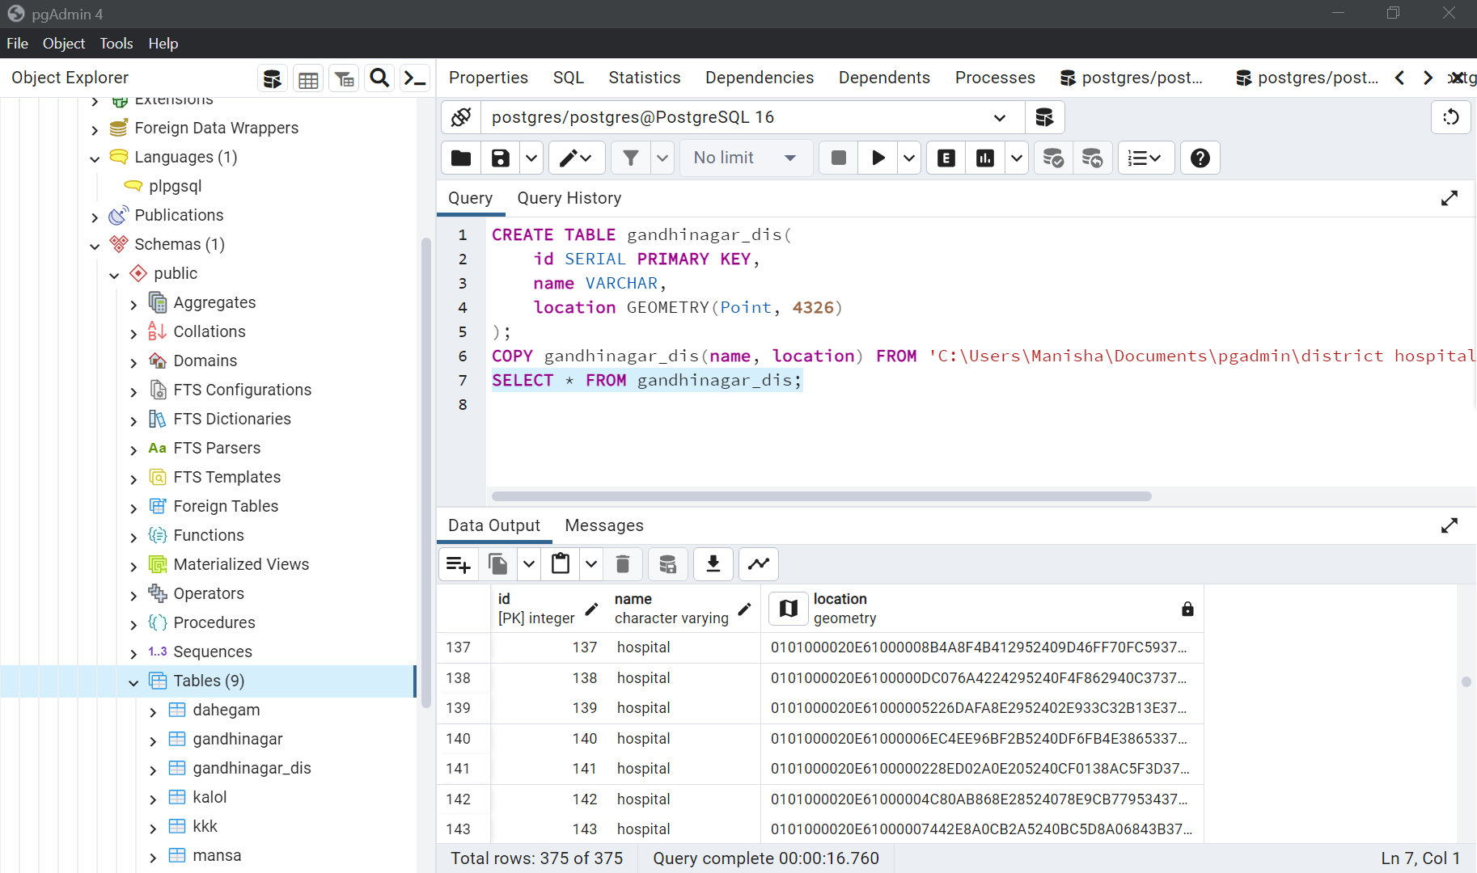

**4.USE OF ARC GIS IN CREATING THEMATIC MAP:**

**MEDICAL FACILITY THEMATIC MAP:**

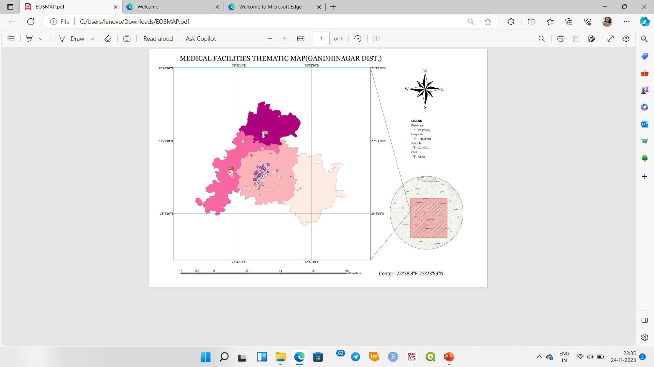

**FINDINGS:**

* Sufficient healthcare facilities are available in Gandhinagar taluk.
* Less availability of healthcare facilities in Dahegam, Kalol and Mansa taluk of Gandhinagar district.

**5.PROBABILITY MAP OF HEALTHCARE FACILITIES:**

**IMPORTANCE:**

**Low Probability Areas:**

* **Sparse Population**: Low probability areas may correspond to regions with a sparse population, where the demand for medical services might be lower.
* **Rural or Remote Areas:** These areas might include rural or remote locations where establishing and maintaining medical facilities can be challenging due to geographical or logistical reasons.
* **Limited Infrastructure**: Low-probability regions may lack adequate infrastructure, making it difficult to support the establishment of healthcare facilities.

**High Probability Areas:**

* **Urban Centers**: High probability areas are often found in urban centers with higher population density, where the demand for medical services is typically greater.
* **Well-Developed Infrastructure**: Regions with well-developed transportation and utility infrastructure are more likely to support the establishment of medical facilities.
* **Strategic Locations:** Areas with strategic importance, such as near major highways or transportation hubs, may have higher probabilities of hosting medical facilities.
* **Proximity to Population Centers**: High-probability regions may be close to population centers where there is a higher demand for healthcare services.

**Implications for Healthcare Planning:**

* **Resource Allocation:** Decision-makers can use the probability map to allocate healthcare resources more efficiently, focusing on areas with a higher likelihood of needing medical facilities.
* **Identifying Gaps:** Low-probability areas may indicate gaps in healthcare coverage, prompting the need for targeted interventions or the development of outreach programs.
* **Emergency Preparedness**: Knowing the probability of medical facility presence in different areas is crucial for emergency preparedness and response planning.

**Public Health Interventions:**

* **Health Disparities**: Probability maps can help identify regions with potential health disparities, enabling public health officials to implement strategies to address these disparities.
* **Health Education:** High-probability areas may benefit from health education programs to manage healthcare resources effectively and encourage healthy behaviors.

**Urban Planning and Development:**

* **Zoning and Regulations**: Probability maps can inform urban planning by influencing zoning regulations to ensure that areas with high probabilities can accommodate the necessary healthcare infrastructure.
* **Infrastructure Investments**: Local governments may use the information to guide infrastructure investments, especially in areas with lower probabilities, to improve healthcare access.

**CREATION OF PROBABILITY MAP:**

Using Machine learning we generated a probability map of different types of healthcare facilities showing high and low probability of healthcare facilities in different regions of Gandhinagar district.

* Red color indicates higher probability of facilities.
* Yellow color indicates medium probability.
* Blue color indicates lower probability.

**CODE:**

**INPUT:**

import pandas as pd

import numpy as np

from sklearn.model_selection import train_test_split

from sklearn.ensemble import RandomForestClassifier

import folium

from folium.plugins import HeatMap

from IPython.display import display

data = pd.read_csv("/content/drive/MyDrive/finalhospitallist1.csv")

X = data[['Latitude', 'Longitude']]

y = data['TYPE']

X_train, X_test, y_train, y_test = train_test_split(X, y, test_size=0.2, random_state=42)

model = RandomForestClassifier(n_estimators=100, random_state=42)

model.fit(X_train, y_train)

probabilities = model.predict_proba(X)

data['probability'] = probabilities[:, i]

gandhinagar_map = folium.Map(location=[23.2156, 72.6369], zoom_start=13)

heat_data = [[row['Latitude'], row['Longitude'], row['probability']] for i, row in data.iterrows()]

HeatMap(heat_data).add_to(gandhinagar_map)

display(gandhinagar_map)

**OUTPUT MAP OF PROBABILITY:**

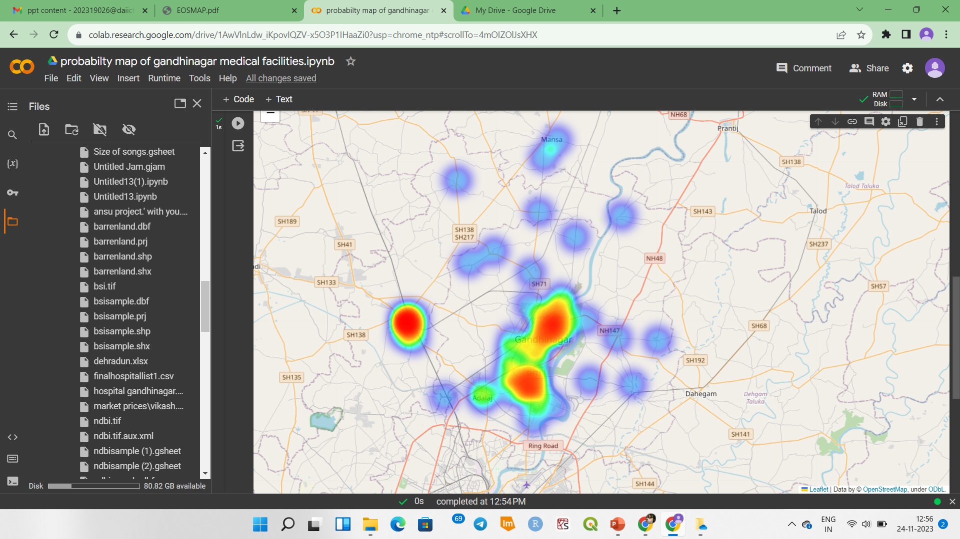

**CONCLUSION:**

In conclusion, the medical facility probability mapping project has provided valuable insights into the distribution and likelihood of healthcare services within our geographic region. Through careful analysis and mapping, we have identified areas with both low and high probabilities of hosting medical facilities, shedding light on critical factors influencing healthcare accessibility.

The project revealed notable spatial disparities in the distribution of medical facilities, with high-probability areas concentrated in urban centres and low-probability regions predominantly found in rural or less densely populated areas. Probability mapping has highlighted potential health disparities, indicating areas where targeted interventions may be needed to ensure equitable access to healthcare services.

**Recommendations for Future Action:**

* **Targeted Interventions:** Develop targeted interventions in low-probability areas, including the establishment of mobile health clinics or telemedicine services to improve healthcare access.
* **Collaboration and Outreach:** Foster collaboration between healthcare providers, local governments, and community organizations to address identified disparities and ensure comprehensive healthcare coverage.

In conclusion, this project serves as a valuable tool for healthcare planning and underscores the importance of considering geographic variations in medical facility distribution. By addressing the implications and acting on the recommendations, we can work towards building a more resilient and equitable healthcare system for our community.

**SOFTWARES USED:**

**REFERENCES AND DATASOURCES:**